CONNECTED, LEVEL 4 2014, What’s the Evidence?  Learning from the Christchurch Earthquakes  by Phillip Simpson  Overview  New learning has come out of the devastation of the Christchurch earthquakes. This article explains how geologists have done research to improve their understanding of earthquakes.  Be aware of possible sensitivities around this subject, especially for those who may have lost friends or family/whānau in the February 2011 Christchurch earthquake.  A Google Slides version of this article is available at www.connected.tki.org.nz. |  |  | 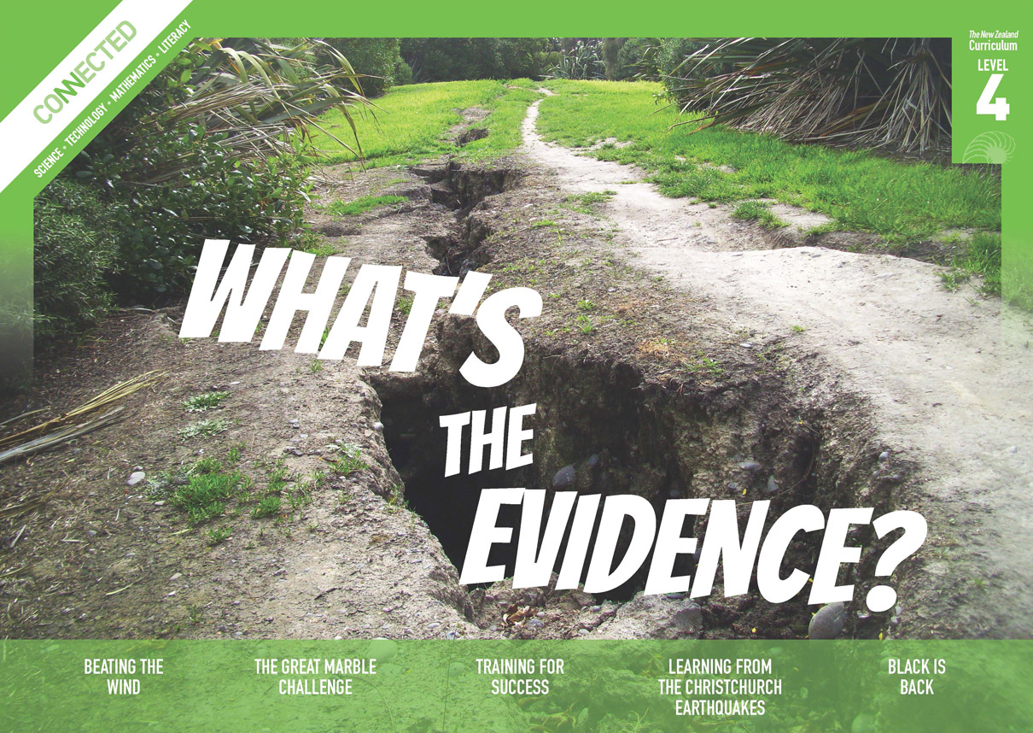  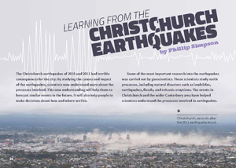
Science capability: Use evidence |  | Text characteristics

Science is a way of explaining the world. Science is empirical and measurable. This means that in science, explanations need to be supported by evidence that is based on, or derived from, observations of the natural world. Students should be encouraged to support their ideas with evidence and look for evidence that supports or contradicts other explanations.  At the core of science is theory building – making better explanations. What sets scientific explanations apart from other ways of explaining the world is their reliance on evidence and their ability to evolve as new evidence comes to light.  For more information about the “Use evidence” science capability, go to http://scienceonline.tki.org.nz/Introducing-five-science-capabilities/Use-evidence |  | - Abstract ideas and concepts.  - Lengthy sections of explanatory text.  - Photographs, text boxes, and diagrams containing main ideas that relate to the text's content.  - Scientific vocabulary and terminology.

Curriculum context

SCIENCE
NATURE OF SCIENCE: Understanding about science  Achievement objective(s)  L4: Students will appreciate that science is a way of explaining the world and that science knowledge changes over time.  Students will identify ways in which scientists work together and provide evidence to support their ideas. |  | PLANET EARTH AND BEYOND: Earth systems  Achievement objective(s)  L4: Students will develop an understanding that water, air, rocks and soil, and life forms make up our planet and recognise that these are also Earth’s resources. |  | Key Nature of Science ideas  - Evidence is based on, or derived from, observations of the natural world.  - Scientific ideas and explanations are supported by evidence.  - Scientists make use of relevant evidence to support or revise their predictions and explanations.  - Scientists sometimes create physical models or computer simulations to test their ideas and gather more evidence.  Key science ideas  - The location, size, and depth of an earthquake, along with other key factors, determine whether we feel it and how much damage it causes.  - Earthquakes and their associated fault movements often cause observable changes in the landscape.

ENGLISH

READING  Ideas  Students will show an increasing understanding of ideas within, across, and beyond texts. |  | INDICATORS  - Makes meaning of increasingly complex texts by identifying and understanding main and subsidiary ideas and the links between them.  - Makes connections by thinking about underlying ideas within and between texts from a range of contexts.  - Recognises that there may be more than one reading available within a text.  - Makes and supports inferences from texts with increasing independence. |  | THE LITERACY LEARNING PROGRESSIONS  The literacy knowledge and skills that students need to draw on by the end of year 8 are described in The Literacy Learning Progressions.

Using evidence

- Scientists use empirical evidence to develop theories about how the world works.
- Empirical evidence is data gathered from observations and experiments.
The science capability, Use evidence, is about students developing and considering theories and explanations in the light of evidence (http://scienceonline.tki.org.nz/Introducing-five-science-capabilities/Use-evidence).
Students should be:
- using evidence they have gathered to develop their own explanations about the way the world works
- critiquing explanations offered by others, including scientifically accepted explanations, by considering the evidence that supports them.
Scientific explanations, including those found in museums, in television programmes, on the Internet, and in non-fiction books and texts, often fail to discuss the evidence and testing that led to the development of these explanations.
Teachers can:
- help students to be more critical consumers of science information by being explicitly critical themselves
- model a sceptical stance
- ask questions such as:
  - How do you think people found that out about that?
  - What kind of evidence would support that idea?
  - How could a scientist test that idea?
- use concept cartoons to propose possible explanations. (See http://conceptcartoons.com/what-is-a-concept-cartoon-.html)
When doing practical investigations, teachers can support students to:
- consider a range of possible explanations for their findings
- think about how these explanations fit with the evidence they have gathered
- avoid suggesting that scientific investigations prove anything – rather, investigations provide evidence that supports or refutes a hypothesis or idea.
Establish a science classroom culture by:
- welcoming a range of possible explanations
- encouraging students to consider possible explanations in the light of evidence
- having students draw evidence from their experience
- using questions such as:
  - What have we seen today that supports X’s idea?
  - Has anyone seen anything somewhere else that might be evidence for X’s idea?
- encouraging investigation:
  - What could we do to test X’s idea?
  - What would we expect to happen? Why?
A range of questions and activities designed to get students to use evidence is available on the Science Online website: http://scienceonline.tki.org.nz/Introducing-five-science-capabilities/Use-evidence

Meeting the literacy challenges

The following instructional strategies will support students to understand, respond to, and think critically about the information and ideas in the text. After reading the text, support students to explore the key science ideas outlined in the following pages.

TEACHER resources

Want to know more about instructional strategies? Go to:
- http://literacyonline.tki.org.nz/Literacy-Online/Teacher-needs/Reviewed-resources/Reading/Comprehension/ELP-years-5-8
- “Engaging Learners with Texts” (Chapter 5) from Effective Literacy Practice in Years 1 to 4 (Ministry of Education, 2003).
Want to know more about what literacy skills and knowledge your students need? Go to:
- http://literacyonline.tki.org.nz/Literacy-Online/Student-needs/National-Standards-Reading-and-Writing
- www.literacyprogressions.tki.org.nz/
“Working with Comprehension Strategies” (Chapter 5) from Teaching Reading Comprehension (Davis, 2007) gives comprehensive guidance for explicit strategy instruction in years 4–8.
Teaching Reading Comprehension Strategies: A Practical Classroom Guide (Cameron, 2009) provides information, resources, and tools for comprehension strategy instruction.

INSTRUCTIONAL STRATEGIES

FINDING THE MAIN IDEAS
Tell the students the title and then ASK QUESTIONS to help them predict what the article might be about.
How does the title signal to you what the article will be about?
The earthquakes were terrible disasters. What might we learn from them that would help us in the future?
Have the students read page 20. ASK QUESTIONS to help them make connections to their prior knowledge. Get them thinking about concepts such as seismic activity, the Ring of Fire, the movement of plates and fault lines, and how earthquakes are measured.
What do you know about the consequence of the earthquakes?
What do you know about their causes?
How are earthquakes measured?
Why do you think we get a lot of earthquakes in New Zealand compared with other countries?
Can you recall other learning we have done about geologists and geology?
What other questions might you ask to help you make connections to your prior knowledge about earthquakes? (Students could do this as a think-pair-share activity.)
MODEL how to create and use a graphic organiser to record information from the text about how the earthquakes changed scientists’ thinking.

Previous idea held by scientists | New thinking about this idea | Evidence that changed their thinking
ASK QUESTIONS to prompt the students to think about how scientists and mathematicians use information.
- How do scientists and mathematicians compare two sets of information?
- What would be the best way of comparing the impact of the September 2010 earthquake to the February 2011 earthquake?
- Create a simple diagram that helps you to compare the impact of the two earthquakes.
For some students, you may need to MODEL how to construct a simple Venn diagram to compare the impact of the two earthquakes.
PROMPT the students to notice the devices the writer uses on pages 24–25 to show the four factors that account for the intensity of the second earthquake: “first”, “Secondly … also”, “third”, “Finally”.
PROMPT the students to respond to the text's message.
The text says, “A greater understanding of the processes involved will help us prepare for the future.” How might this happen?

USING DESIGN FEATURES FOR DEEPER UNDERSTANDING
Look at the photograph on page 20.
What can you see in this photograph?
What do you think is happening? What makes you think that?
The caption says that the photograph was taken seconds after the 2011 earthquake hit. What evidence supports this?
PROMPT the students to look closely at the diagram on page 22 showing the process of liquefaction. Have them explain the process, first to a partner and then to a group of four. Repeat this exercise with the diagram on page 24.

DEALING WITH SCIENTIFIC VOCABULARY
EXPLAIN that the glossary is an important part of this article and it will help the students to understand the meaning of a number of the scientific and academic words.

Key science ideas
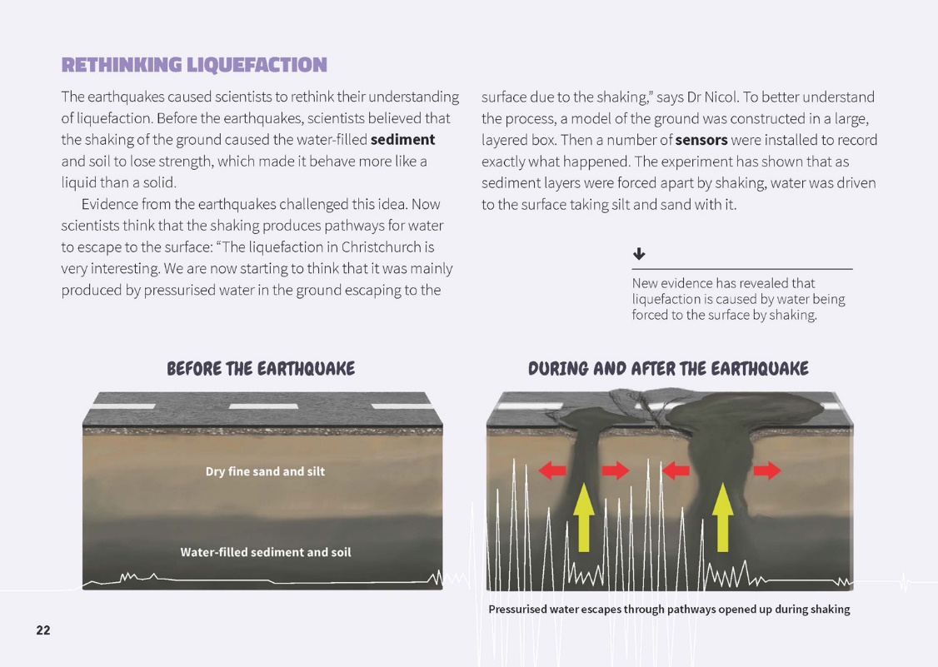 | Scientists create physical models or computer simulations to test out their ideas.  Science knowledge changes over time as new evidence arises.  Scientists use evidence to support or revise their predictions and explanations.
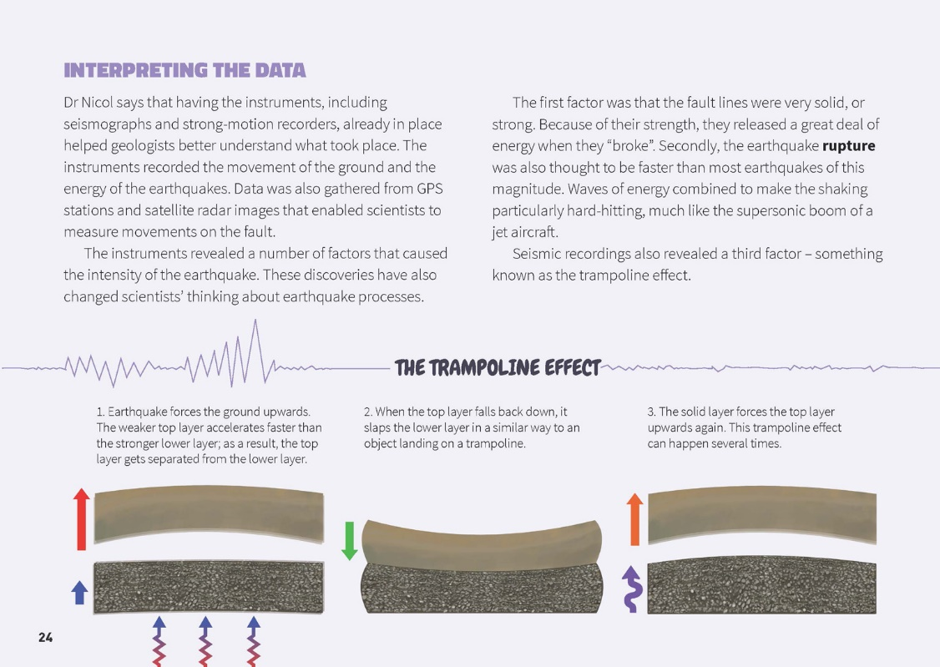 | Scientists revise their thinking when new evidence arises.  The location, size, and depth of an earthquake, along with other key factors, determine whether we feel it and how much damage it causes.  Evidence is based on observations of the natural world.

Exploring the science
Some activities focus directly on the science capability of “using evidence to support ideas” and the Nature of Science strand. Other activities extend student content knowledge. You are encouraged to adapt these activities to make the focus on Nature of Science explicit and to support students to develop the capability of using evidence to support ideas.

LEARNING FOCUS
Students identify how new evidence can cause scientists to revise their ideas.

LEARNING ACTIVITIES

Activity 1: Understanding geological forms and processes
Landforms
Working in pairs, the students use plasticine to create eight different landforms, as described in “The Landform Expedition” from Making Better Sense of Planet Earth and Beyond (Activity 9, page 34). After they have created each landform, they discuss the landform or process they have modelled and construct a definition.
Share the definitions as a class and connect the learning to the text and to your local environment.
Are any of these landforms evident in our local environment?
From what you know so far, which of them do you think exist in Christchurch?
Use this activity to introduce important geological concepts. Make sure you keep using this language so it is reinforced.
Faults
Have students explore faults using chocolate bars as models. Give pairs of students a small Moro bar (or similar).
Turn the bar upside down so that the thick chocolate top is at the bottom.
Make a cut across the middle of the bar. Do not cut right through the bar – try to leave the thick chocolate (now at the bottom) intact.
Turn the bar over. Move the ends of the bar on either side of the cut in different directions – push them together, pull them apart, and move them sideways. What happens to the chocolate crust?
Watch the cracks in the crust carefully as you move the ends again. How and where does the crust move?
Ask: What do you think might happen to the surface of the Earth if things underneath it move like the chocolate bar? What do the cracks in the model represent?
Explain that the edges of the cut in the chocolate bar are like two tectonic plates. The chocolate crust is behaving in a similar way to the layer of rock and earth above the tectonic plate boundaries: it cracks and moves along fault lines. The cracks and faults come under pressure and move as a result of the stresses beneath them.

Activity 2: Finding fault
The article explains that scientists use seismic instruments to work out the location and movement of earthquakes. Section Two of Earthquakes: Feeling the Earth Move, Building Science Concepts book 40, focuses on how to locate and measure earthquakes. In Activity 1 (page 11), students identify fault lines in photographs. They build the understandings that:
fault lines are the surface evidence of movement within the rocks of the Earth's crust
some places experience more earthquakes than others.
Use Activity 2 (page 12) to find out more about how scientists measure earthquakes.
The Science Learning Hub offers a rich array of resources within its Earthquake context (links below). This includes background material on seismic engineering that includes photographs and videos. See also the GNS page on Earthquakes (www.gns.cri.nz/Home/Learning/Science-Topics/Earthquakes). This includes video flyover of the Greendale Fault.
LEARNZ offers a series of field trips that look at the use of geospatial skills, data, and tools following the Canterbury earthquakes (www2.learnz.org.nz/core-fieldtrips.php).
Extension
The Christchurch earthquakes revealed previously unknown faults. Scientists needed to fit the new information to what they already knew about our country's geological makeup. In the Science Learning Hub student activity “The Extra Piece”, students experience what this might be like. In the activity, students assemble a tangram and then try to reassemble the tangram with an additional piece. Parallels are drawn to particular aspects of the Nature of Science.
Talk about how learning often involves reorganising our original ideas to accommodate new ones.

Activity 3: Liquefaction
Reread the information about liquefaction on page 22 of the article. What evidence led the scientists to change their theories about liquefaction?
Use Activity 2 on page 15 of Earthquakes: Feeling the Earth Move, Building Science Concepts book 40, as a practical demonstration of how liquefaction occurs. As they do the activity, have students make observations. ASK: How do your observations support the new explanation on page 22? Do you see any evidence that contradicts the explanation?
The Science Learning Hub article “Liquefaction” explains the causes of liquefaction and how we can protect against it. It includes video material from Christchurch.

Activity 4: Is base isolation always appropriate?
A structure built directly on the ground will possibly be damaged during an earthquake. A building built away (isolated) from the ground on pads known as base isolators may not move at all. An example of this is Christchurch Women’s Hospital, which suffered little damage in the February 2011 earthquake.
The Science Learning Hub student activity “Best Base Isolator” describes how students can use a model to investigate the effectiveness of different base isolators.
Google Slides version of “Learning from the Christchurch Earthquakes” www.connected.tki.org.nz

RESOURCE LINKS

Building Science Concepts, Book 40 – Earthquakes: Feeling the Earth Move
“The Changing Landscape” in Making Better Sense of Planet Earth and Beyond, pp. 32–43.
School Journal
“Earthquake” by Lynn Davis. School Journal Level 3, November 2011. (TSM available at http://literacyonline.tki.org.nz/Literacy-Online/Teacher-needs/Instructional-Series/School-Journal/Teacher-support-materials)
“One City – Two Earthquakes” by Jenna Tinkle. School Journal Level 3, November 2011. (TSM available at http://literacyonline.tki.org.nz/Literacy-Online/Teacher-needs/Instructional-Series/School-Journal/Teacher-support-materials)
Quake, Rattle, and Roll by Sarah Wilcox. School Journal Story Library, Level 3, 2013 (TSM available at www.schooljournalstorylibrary.tki.org.nz)
Science Learning Hub
“Earthquakes” at www.sciencelearn.org.nz/Contexts/Earthquakes
“Frank Foster Evison (1922–2005)” (heritage scientist who specialised in earthquake prediction) at www.sciencelearn.org.nz/Science-Stories/Our-Heritage-Scientists/Frank-Foster-Evison
“How Do Base Isolators Work?” at www.sciencelearn.org.nz/Contexts/Earthquakes/Looking-Closer/How-do-base-isolators-work
“Liquefaction” at www.sciencelearn.org.nz/Contexts/Earthquakes/Looking-Closer/Liquefaction
“Liquefaction Explained” at www.sciencelearn.org.nz/Contexts/Earthquakes/Sci-Media/Video/Liquefaction-explained
“NZ Research” (earthquakes) www.sciencelearn.org.nz/Contexts/Earthquakes/NZ-Research
“Science Ideas and Concepts” (including faults, plate tectonics, seismic waves) at www.sciencelearn.org.nz/Contexts/Earthquakes/Science-Ideas-and-Concepts
“Seismic Engineering” at www.sciencelearn.org.nz/Contexts/Earthquakes/NZ-Research/Seismic-engineering
“Shaken Not Stirred” at www.sciencelearn.org.nz/Contexts/Earthquakes/Sci-Media/Video/Shaken-not-stirred
“Student Activity – Best Base Isolator” at www.sciencelearn.org.nz/Contexts/Earthquakes/Teaching-and-Learning-Approaches/Best-base-isolator
“Student Activity – The Extra Piece” at www.sciencelearn.org.nz/Nature-of-Science/Teaching-and-Learning-Approaches/Student-activity-The-extra-piece
“Teaching and Learning Approaches” (earthquakes) at www.sciencelearn.org.nz/Contexts/Earthquakes/Teaching-and-Learning-Approaches
“Timeline – Earthquakes” at www.sciencelearn.org.nz/Contexts/Earthquakes/Timeline
GNS Science
“Earthquakes” at www.gns.cri.nz/Home/Learning/Science-Topics/Earthquakes
“Canterbury Earthquake” at www.gns.cri.nz/Home/Our-Science/Natural-Hazards/Recent-Events/Canterbury-quake
Virtual field trips, available from LEARNZ, www2.learnz.org.nz/core-fieldtrips.php
- Canterbury Earthquake (2011)
- Canterbury Earthquakes – Lessons for New Zealand (2012)
- Canterbury Earthquakes – More Lessons for New Zealand (2013)
- Geohazards – Volcanoes, Tsunami, Landslides, Earthquakes, and Hydrothermal Activity (2014)
- Geospatial – The Use of Skills, Tools, and Data by People in Canterbury (2013)
- Geospatial – How Location Based Information Is Helping the rebuild of Christchurch (2012)
“Professor Euan Smith on lessons from the quake” from Science Media Centre NZ, www.sciencemediacentre.co.nz/2010/09/06/professor-euan-smith-on-lessons-from-the-quake/
Shaken not Stirred from Sciblogs (A blog about earthquakes and fault lines in New Zealand) at
http://sciblogs.co.nz/shaken-not-stirred/tag/earthquake/

